

Providing Virtual Education to Under Privileged People of Delhi Slum

Donor Agency:

**Oil and Natural Gas Corporation Limited**

Plot No. 5A- 5B Nelson Mandela Road, Vasant Kunj, New Delhi – 110 070

**June 2020**

Proposal for seeking fund under Corporate Social Responsibility

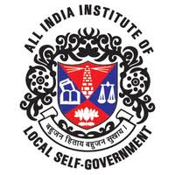

Proposal Placed by:

**All India Institute of Local Self Government**

11/13, Botawala Building, Horniman Circle, Fort, Mumbai-400 023

Contents

1. Implementing Agency Background 4

1.1 Brief description 4

1.2 Project Background 4

2. Project Details 6

2.1 Details of the proposed CSR project to be undertaken 6

2.2 Brief objectives of the project 7

2.3 Assessment/ Baseline survey for the proposed project 9

2.4 Targeted beneficiaries under proposed CSR project 10

2.5 Detail timeline/duration of the proposed project 10

2.6 Budgetary Requirement for the Project 11

2.7 Monitoring mechanism for the project 12

2.8 Project Sustainability Plan 12

2.9 Branding/Visibility/Mileage to ONGC from the Proposed CSR Project 12

Registration Certificate 14

UNDERTAKING 15

**EXECUTIVE SUMMARY**

|  |  |
| --- | --- |
| **About Project** | |
| Title of the proposed project | **Proposal for Virtual Education to Under Privileged People (UPP) of Delhi Slum** |
| Proposed project activities | 1. Creation of basic smart infrastructure at the nearest place, where the UPP can easily reach and avail the benefits. 2. Capacity building of the UPP to help them understand the benefits linked with the Virtual education system. 3. Linking UPP to job portal to help them fetch them respectable earning. |
| Objectives of the proposed project | 1. To improve access and quality of primary education to the UPP. 2. To enhance the capacity of stakeholders thru better quality of education 3. To develop a holistic educational model to ensure fulfillment of Right to Education 4. To ensure improve the social and gender equity through quality education to UPP 5. To give rights of equality to education |
| Who are direct beneficiaries with approx. number | Under privileged People having less money, education than the other people in a society and having fewer advantages, privileges, and opportunities than most people have. The phased wise education shall be provided to approx. 50 such people in single stage. |
| Project location | Delhi |
| Total project Budget Requirement | |  |  |  | | --- | --- | --- | | **Consolidated Project Budgeting** | | | | CapEx | Rs. | 500000 | | OpEx | Rs. | 1557600 | | **Total Project Budget Requirement** | **Rs.** | **2057600** | |
| Fund Donor Agency | **Oil and Natural Gas Corporation Limited**  Plot No. 5A- 5B Nelson Mandela Road, Vasant Kunj,  New Delhi - 110070 |
| Proposed project duration | Six Month (from the date of release of fund) |

|  |  |
| --- | --- |
| **About Implementing Organization/Agency** | |
| Name & registered address of implementing agency/ (fund sourcing agency) | **All India Institute of Local Self Government**  11/13, Botawala Building,  Horniman Circle, Fort, Mumbai-400 023 |
| Goals and objectives of the agency as per Memorandum of Association/ Bylaws/ Articles of the Association | **Goal:**  Empower local bodies to deliver to each citizen his rights to health, education, safety, participation and development through excellent governance and service delivery.  **Objectives:**  Among the prominent objectives of the institute is to advance the knowledge of the principles and practice of local governance among urban local bodies. Our mandate is to strengthen and improve local government institutions through capacity building by organizing training courses and programmes. |
| Legal status of the agency and date or Registration | AIILSG has been duly registered under the Societies Registration Act, XXI of 1860  **Date of Registration:** 22-10-1970 |
| Contact details  (office no., mobile no. and e-mail) | Mr. Ravi Ranjan Guru  Deputy Director General  (T): +91-11-28525465/ 28521783/ 25822117  (M): +91- 9818098411  Email: raavi.guru@gmail.com |

# Implementing Agency Background

## Brief description

Founded in 1926, AIILSG is one of the oldest NGOs in India and Asia, having reputed corporate funders like - National Stock Exchange Foundation, Tata Power Rallis India (A TATA enterprise), Eagle Burgmann, Alkem Laboratories and Aroma Agrotech etc. Organization’s unmatched standing of more than ‘93 years’ with “Pan India Presence” is working in close association with States and Central Government, National and International Agencies, with “decades of dedicated service” in the field of Education, Training, Research & Consultancy empowering the Local Bodies to usher in Good Local Governance, across the country.

AIILSG has been training municipal officials and elected representatives at various levels. AIILSG runs separate training and capacity building programs and training courses as per the requirement of ULBs through its 40+ centres and affiliated centres across India to build an efficient workforce for municipal bodies. Beside AIILSG is also running skill development programmes in Gujarat, Rajasthan and Jharkhand to contribute to Skill India Mission. The main targeted areas are:

* Training of civic officials to enhance abilities for efficient delivery of civic services
* Skill development programmes in partnership with government departments and corporates
* E-governance inputs to ULBs to improve their effectiveness
* Capacity building of ULBs for implementing schemes like AMRUT, PMAY, SCM and SBM.

AIILSG is currently operating in States of Andaman & Nicobar Island, Chhattisgarh, Dadra & Nagar Haveli, Daman & Diu, Delhi, Goa, Gujarat, Haryana, Himachal Pradesh, Jharkhand, Madhya Pradesh, Maharashtra, Meghalaya, Mizoram, Punjab, Rajasthan, Sikkim, Tamil Nadu, West Bengal etc.

AIILSG is empaneled with Ministry of Housing and Urban Affairs as training entity for imparting training to municipal officials under Atal Mission for Rejuvenation and Urban Transformation (AMRUT) and Integrated Capacity Building Program (ICBP) under (SBM, SCM, PMAY, Day-NULM) for Administration, Finance & Revenue, Engineering & Public Health, Town Planning and Urban Social Aspects.

## Project Background

Education is a powerful tool which empowers communities to turn around their lives. If any member of a family is educated, especially women, it can help coming generations to break the inter-generational cycles of poverty. Education is a great enabler – it makes people skilled and equips them to engage in meaningful professions and thus contribute to their own and society’s socio-economic well-being. In India, even today, millions of people go without any access to education. As many as 16 crore people in India continue to remain out of education. It’s a major social problem plaguing modern-day India and strong measures are needed to ensure the benefits of education touch everyone.

The right to education is a fundamental right, but thousands of people across India remain deprived of it. According to All India Education Survey, less than half of India's children between the age of six and 14 go to school. India’s literacy rate is currently 69.3 percent, and according to the 2011 Census, India’s eastern region had the lowest literacy rate of 59.6 percent. There are 472 million children in India under the age of 18 years. This constitutes 39% of the total population in the country (Census 2011). The report further elaborates the following:

* 1 in 4 children of school-going age is out of school in our country – 99 million children in total have dropped out of school (Census 2011)
* Out of every 100 children, only 32 children finish their school education age-appropriately (District Information System for Education (DISE) 2014-15)
* Only 2% of the schools offer complete school education from Class 1 to Class 12 (District Information System for Education (DISE) 2014-15)

Recent community-based surveys done in 28 cities and eight rural districts in the country find that not more than 30 per cent of school children in the age group 6 to 14, in an educationally advanced state like Maharashtra, can read simple text fluently or do basic arithmetic sums.

The aim of education imparted should be to bring changes not only in the amount of knowledge gained but also in the abilities to do so, to think and to acquire habits, skills and attitude which characterize an individual who is socially accepted and adjusted. Education is a means to an end, we believe in the “empowering” effect of education and its ability to enable people to develop a critical questioning attitude towards society, government, existing gender and cultural stereo types.

We at AIILSG, believe that quality education is a key to overcoming poverty in a single generation. And the same is fundamental in creating a future for human security, community development and progress of the nation. We at AIILSG works for providing an enabling environment, to kindle the light of education to each deprived person, through creative teaching, providing appropriate teaching aids, improving infrastructure facilities, starting libraries, community mobilization and literacy promotion etc.

We cannot ignore the limitations imposed by the realities of our systems nor do we aim to. Instead of creating parallel structures, we supplement and work in synergy with existing Government and other initiatives in providing education to all. In our endeavour to improve the quality of education, we aim and work for:

* Achieving 100% class enrolment and retention
* Capacitating teachers to be effective as facilitators of learning
* Promoting the culture of reading
* Equipping beneficiaries with the basic tools of education
* Providing conducive learning environment

The project is based on a holistic concept model of ‘Right to Education through Right Education’. Right to Education (RTE) have a crucial focus on education for the People from disadvantaged or underprivileged sections.

The project builds on the following aspects emphasized in RTE:

* Quality Education
* Social Equity (focus on SC and STs, People from disadvantage sections)
* Gender Equity
* Building on provisions for ‘Special Training for Disadvantage People’

The project shall be implemented in the slum area of Delhi, where the maximum population of the underprivileged resides. Currently it shall be taken up at one place and then shall be replicated in other slum areas, depending on the budget availability, place, participants and time. The resources shall be accordingly planned and will be deployed at task.

# Project Details

## Details of the proposed CSR project to be undertaken

The project is based on the **Virtual Class Education** is the use of advanced technology in education to make it more interesting & creative as audio-visuals effects used in session that impact more and increases the brain retention process. **Virtual Class Education** brings complete transformation in learning that is far beyond the traditional methodology of teaching.

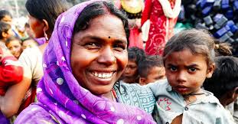Advantages of Virtual Education:

* Personalized learning: Students can learn at their own time and phase
* Long distance learning
* Enhances collaboration and communication
* Real-time teaching and learning
* Effective and efficient time management
* Gives students and teacher a worldwide exposure
* 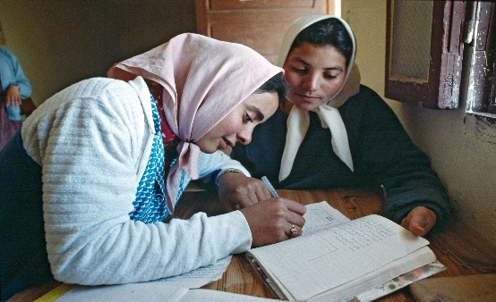Accessed to everyone equally from anywhere and at anytime
* Affordable
* Introduces students and educators to education technology
* Comprehensive online tutorials
* Encourages digital and smart classrooms
* Improves Visualization

This virtual education classes also help for the GO GREEN CONCEPT. Smart technology follows a dynamic information sharing approach and there is no need of paper, pen, pencil & printouts, thus stepping into 'Go Green Concept'. We can say, this is one of the major benefits of virtual education classroom technology to keep nature clean and green.

Increased Productivity, Data shared with the help of intelligent class technology is presented in a visual format that is more likely to engage the students. Not only students’ involvement but, they understand things more easily in minimal time. This motivates students and teachers accomplish pretty good results leading to improved productivity.

## Brief objectives of the project

* Smart learning environments objective to assist, engage, and enrich the learning experience of learners by providing support to them.
* To enables teachers to access multimedia content and information that can be used for teaching students more effectively.  Pedagogically sound and visually rich curriculum resources.
* To enables teachers to express their views and ensures that every child is understanding the undertaken concept which ultimately affects his achievement.
* To make possible for the concepts to be understood clearly. To makes abstract concept real.
* To have interactive and live teaching to elaborate and compare different objects and perceptions towards the concepts
* To design a module of virtual class which allows a student to visualize the concept much better than static images. Visuals and animations that students will never forget.
* To move a step towards development where students’ achievement is highlighted.
* To makes learning an enjoyable experience for students. Activities and games to make learning process easy.
* To make effective blending of technology with the classroom, and to Inform the teachers of classroom events
* To instruct simultaneously remote and local students.
* To improve creative thinking in learning process to visualize the concepts and practices with model and demonstrations.
* To optimize the use of e-resources wise e-books, e-journals, protocols, lecture notes, documentaries and so on.
* To customized content as per the school’s scheme of work and to provide facility to update the content.
* The **virtual classroom** is a modern intelligent learning environment that integrates technologies such as the internet and virtual terminals.
* **Virtual classroom**, with deep interaction as its core feature, has been one of the research hotspots in the field of education.
* It possesses a variety of features, such as the real-time interaction, environmental control.
* Make the classroom a virtual Class that provides an instructor station equipped with computer and audiovisual equipment
* Often include DVD and other productivity software e.g. Power point presentations, and more displayed through a data projector.
* To develop a holistic educational model for strengthening and enriching the demand side of Right to Education
* To improve the social equity and gender equity through quality smart education to slum dwellers
* To ensure inclusive and equitable quality education and promote lifelong learning opportunities for all
* Increased awareness about better health and hygiene behavior in the community.

**In general, virtual classrooms are equipped with the following:**

* Desktop or Laptop
* Ceiling mounted LCD projector and projection screen
* Connectivity for PC laptops
* DVD System
* Sound System
* Touch screen control system
* Microphone (wireless hand-held and/or lavaliere)
* Mouse
* Interactive whiteboard
* USB/ HDMI facility

**The Cocepts of Virtual Class**

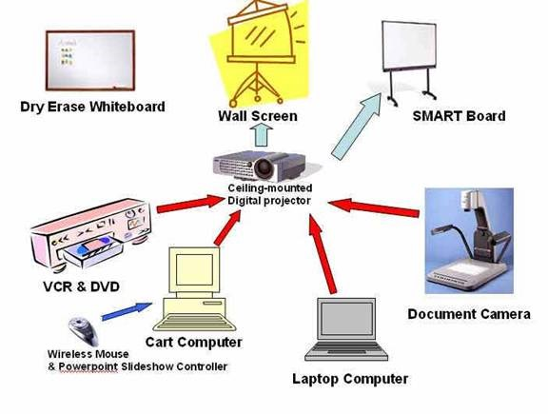

## Assessment/ Baseline survey for the proposed project

**Demographics:**

|  |  |
| --- | --- |
| **Particulars** | **Delhi** |
| City population | 11,034,555 |
| Females | 5,152,438 |
| Males | 5,882,117 |
| Sex Ratio | 876 |
| Children | 1,238,350 |
| Girls | 576,482 |
| Boys | 661,868 |
| Child Sex Ratio | 871 |
| Total Slums | 675 |
| Slum population | 1,785,390 |
| % of Slum population in Total Population | 16.18 |
| SC/ ST Population | 482,870 |
| Females | 811,061 |
| Males | 974,329 |
| Slum Children | 229,029 |
| Source: Census of India 2011 (Population Data, Age wise data) | |

**Economy:**

Delhi is highly prosperous but at the same time it depicts high degree of inequalities. Delhi city is considered as home to high proportion of slum dweller populations. 16.18% of the total population 17.85 lacs reside in 675 slums in Delhi. The slum community is heterogeneous in nature with substantial proportion of socially disadvantaged (SCs, OBCs and minorities) populations. Many of the slum dwellers are employed in the unorganized sector, too in unskilled jobs. They hardly have any social security. The slums have very high population density due to overcrowding. The slum habitations have poor access to basic amenities such as safe drinking water, sanitation facilities, proper roads, closed gutters. The slums are characterized by poor living conditions, impoverished ambience for education of People and degraded environment. Without sustainable livelihood options, the slum populations of Delhi are living in abject poverty. They are caught in severe cycle of poverty, illiteracy and unemployment.

**Education Status:**

The poor living conditions in slums are detrimental in many aspects, particularly for People in terms of health and education. Living in dilapidated conditions leads to health issues which have a direct impact on People’s learning capacities, concentration abilities and attendance. Despite being large cities, the aspects of access to education and quality education to under- privileged People hitherto remains neglected. There is considerable proportion of attendance - irregularity of these slum dweller People. There is high student to classroom ratio for these People making the learning virtual environment difficult for them. Based on intensive focus group discussions conducted with the parents and the People in Delhi, the major crucial issues regarding virtual education are:

* Lack of computer, improper, lighting and poor air activity affect the overall academic performance.
* Poor learning environment at home and at the community level
* Low enrolment especially of the disadvantaged groups in schools
* High absenteeism
* Poor retention in schools especially of girl child
* There is poor attendance in schools of these People, insufficient focus on education and poor learning attainments.
* Illiterate parents have a common perception that the economic gain from education in not possible for them. This perception of poor returns from education is mainly because the adults are working in the unorganized sector and have not seen the advantages on livelihoods within the organized sector. Therefore, this view further leads to low motivation to gain virtual education.

The project through education will also focus on socio-economically disadvantaged slum populations. There will also be special emphasis on the virtual education of girl child since the gender gap in enrolment are very high for girls belonging the disadvantaged groups.

## Targeted beneficiaries under proposed CSR project

Total targeted beneficiaries shall be 50 (fifty) in numbers in a single batch, which will last for a period of 6 (six) months. Post that next batch with equal numbers at different location shall be conducted having students of all genders, all age groups, all social classes & all religion. The priority shall be given to one who wish to volunteer themselves first and have passion to pursue learning. Though the efforts shall be to motivate all and help them get inclined to seek knowledge through smart means. The project will focus on socio-economically disadvantaged slum populations. There will be special emphasis on the education of girl child since the gender gap in enrolment and the dropout rates are very high for girls belongs to the disadvantaged groups.

## Detail timeline/duration of the proposed project

|  |  |  |  |  |  |  |  |  |  |  |  |
| --- | --- | --- | --- | --- | --- | --- | --- | --- | --- | --- | --- |
| **Coverage: Six Month** | | | **Days** | | | **Months** | | | | | |
| **Sr.** | **Head** | **15** | | **15** | **2** | | **3** | **4** | **5** | **6** |
| **1** | Understanding status of education of the People from disadvantaged communities residing in Delhi Slum areas |  | |  |  | |  |  |  |  |
| **2** | Daily Two hours class (either in evening/ morning) |  | |  |  | |  |  |  |  |
| **3** | Home visit to parents of disadvantaged People and liaising with government officials (to help them understand the advantages of education and avail the benefits) |  | |  |  | |  |  |  |  |
| **4** | Development of People’s Resource Center at site |  | |  |  | |  |  |  |  |
| **5** | Knowledge Management and Dissemination |  | |  |  | |  |  |  |  |
| **6** | Regular Counseling of students/ parents/ beneficiaries |  | |  |  | |  |  |  |  |
| **7** | Project Monitoring and Evaluation |  | |  |  | |  |  |  |  |

## Budgetary Requirement for the Project

|  |  |  |  |
| --- | --- | --- | --- |
| **Capital Expense for Virtual Education Class Room** | | | |
| Computer (PC) with basic configuration | 5 | 35000 | 175000 |
| Printer | 2 | 5000 | 10000 |
| Benches | 25 | 5000 | 125000 |
| Chairs | 60 | 1500 | 90000 |
| Table | 6 | 3000 | 18000 |
| Table fan/ cooler | 6 | 9000 | 54000 |
| White Board | 2 | 5000 | 10000 |
| Msc. |  |  | 18000 |
| **Total One Time Expense (Rs.)** | | | **500000** |

|  |  |  |  |  |  |  |  |
| --- | --- | --- | --- | --- | --- | --- | --- |
| **Operation and Management Expenses** | | | | | | | |
| **Sr.** | **Head** | **Unit** | | **No. of units** | **Unit rate** | **Total (Rs.)** | |
| **1** | **Honorarium** | | | | | | |
| **1.1** | Project Director | 1 | Months | 6 | 50,000 | 300000 | |
| **1.2** | Project Manager | 1 | Months | 6 | 35,000 | 210000 | |
| **1.3** | Shiksha Mitra | 2 | Months | 6 | 20,000 | 240000 | |
| **2** | Rent of People’s Resource Center | Months | | 6 | 20,000 | 120000 | |
| **3** | Staff Commuting | Per Day | | 720 | 250 | 180000 | |
| **4** | Workshop | Per Workshop | | 6 | 10000 | 60000 | |
| **5** | Electricity/ Water | Month | | 6 | 10000 | 60000 | |
| **6** | Miscellaneous | Month | | 6 | 5000 | 30000 | |
| Sub Total | | | | | | | 1200000 |
| **7** | Administrative Charges (@10%) | | | | | | 120000 |
| Total Six-Month Expenses | | | | | | | 1320000 |
| **8** | GST (@18%) | | | | | | 237600 |
| **Total O&M Cost (Rs.)** | | | | | | | **1557600** |

|  |  |  |
| --- | --- | --- |
| **Consolidated Project Budgeting** | | |
| CapEx | Rs. | 500000 |
| OpEx | Rs. | 1557600 |
| **Total Project Budget Requirement** | **Rs.** | **2057600** |

## Monitoring mechanism for the project

* **MIS System:** keeping the track of People’s progress
* **Frequent Meeting (Proposed per week):** With parents/ beneficiaries & Authorities
* **Project Meetings:** There will be two types of project meetings
* **Monthly Monitoring Meetings:** These will be conducted at every site.
* **Learning Workshops:** For review of progress capturing learnings and policy implications emerging from the project. Participants will be: Entire project team people of repute, Monthly report
* **Report:** Progress report of attendee weekly & Monthly report
* **Financial Report:** Audit statements, sending financial audited statement to donor agency

## Project Sustainability Plan

The sustainable plan will be in three-fold:

* Strengthening the demand side
* Capacity building of stakeholders – parents, community elders
* Strengthening the supply side: by working with the mainstream virtual education stakeholders
* Undertaking sensitization and capacity building of teachers, functionary’s education department, following up on enrolment, dropouts and retention
* Close rapport and liaising with the schools and the education department will be built to enable furtherance of this cause
* Fostering and strengthening grassroots community organizations-
* In city within every settlement: Bal Panchayat, parents
* At cluster level: apex body of education with Parents in each cluster of 600 People

## Branding/Visibility/Mileage to ONGC from the Proposed CSR Project

Branding will be very significant in the entire project because it should be known in the society that what kind of work is done in the society and by whom. We have opted out some of the best way to brand and make donor visible in the society. These are:

* **Learning workshop:** This is one of the best ways to brand the company where almost hundreds of underprivileged People will be invited along with their parents to participate in the workshop. In this workshop, media will also participate. So, through this workshop the name of donor can be reached to a large population.
* **People Resource Center:** Resource Centre will be set up where special training programme for People, following up on progress on education, enrolment, retention, grassroots facilitation will be taken place. This center will be set up at that place where most of the people can observe it. In the center, the big hording will be placed where the donor brand will be promoted.
* **Urban Update:** Urban Update is an English monthly offering a signature blend of reporting and commentary on urban development, municipal affairs, innovation, sustainability, environment, energy efficiency, mobility, science and technology, and business, along with case studies and success stories from Indian and global cities and towns. The magazine is an initiative of the All India Institute of Local Self-Government (AIILSG), which reports on day-to-day urban affairs. The magazine plays a special and diversified role in urban development as a primary, indispensable link among stakeholders directly or indirectly connected to the cause, a wellspring of writing and imagery that nurtures community and reinforces magazine’s vision of evangelizing urban infrastructure, governance, culture, safety and security, and, above all, sustainability. Urban Update has subscribers all across the country in the huge number. Through Urban Update this project can be explored to the Urban Update Subscribers. So, through Urban Update project along with donor can achieve a huge popularity.
* **Knowledge Management and Dissemination:** All the intended beneficiaries will be equipped with some study material and stationeries. In all of these, the brand name of all the donors will be mentioned.

# Registration Certificate

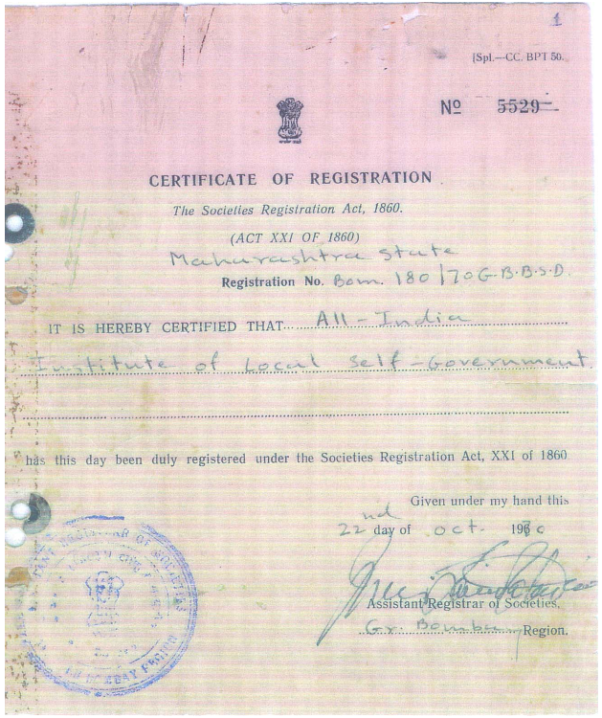

**[Format for Affidavit]**

**(Affidavit on Rs. 100 non-judiciary stamp paper duly notarized)**

# UNDERTAKING

1. We **All India Institute of Local Self Government** (Name of agency). PAN No. **AAAAA0702A** Registered at **All India Institute of Local Self Government 11/13, Botawala Buildig, Horniman Circle, Fort, Mumbai -400 023** (Registered address) have not taken any support from any of the ONGC work centers including Headquarters & corporate office during the financial year 2015-16
2. There are no pending disputes or enquires in connection with cheating misappropriation of funds exploitation of beneficiary. Etc. on the name of **All India Institute of Local Self Government** (Name of agency). The organization has never been “Black listed “or “Reprimanded, by Govt/Govt Agencies/CPSEs/NCRS Hub or by reputed private organization.
3. The proposed project in neither covered under any existing scheme of Govt. of India / State Organization to ensure that there no duplicity of the CSR activity under reference.
4. Any of Board of Directors/Trustees/Executive Committee members of **All India Institute of Local Self Government** (name of agency) or the Organization itself does not have any material or pecuniary relationship of transactions with ONGC, its Promoter, its Senior Management or its Holding Company, its Subsidiary and Associates which may influence the process of administrative approval or financial concurrence or fund disbursement for the proposed project.
5. We **All India Institute of Local Self Government** (Name of agency have not directly or indirectly supported/contributed by any political party or its affiliations and vice-versa.
6. We **All India Institute of Local Self Government** (Name of agency) assure that if ONGC approves any financial support towards proposed CSR project.
7. We will submit a Fund Utilization Certification to ONGC, issued by a Chartered Accountant as per the given format at Annexure-VI of CSR Compliance Checklist.
8. We will retain all relevant documents like Cash Book, Bank Book Ledger, Journal Relevant Bills, Vouchers and Receipts etc. for a period of at least 03 years from the Project/Event.
9. That during this period of 3 years agency will allow authorized representative (s) of ONGC for audit (s) / inspection (s) of above documents as and when asked by ONGC.
10. That during the period of 3 years as mentioned above, on ONGC demand agency will provide the desired documents/information pertaining to income & expenditure detail of the project/ event including copies of relevant Bills, Vouchers and Receipts etc. for internal and/or external purposes (for supplying to 3rd party) as per law.

**Declaration:**

I hereby deciare that whatever has been stated above is true to the best of my knowledge, correct and nothing has been concealed there from.



Date/ Place: ………..

Authorized Signatory